**How to make your Binoculars Craft**

**What you'll need:**

* 2 toilet paper rolls or card and roll tube
* Construction paper
* Glue
* Scotch tape
* Scissors
* Stickers, crayons, etc.
* Optional - string

**How to make your Binoculars Craft**

1. Cut a piece of construction paper so that it will wrap completely around one of the toilet paper rolls. Tape the construction paper in place and then repeat this process with the other roll.
2. Roll a piece of scotch tape into a donut and stick the two toilet paper rolls together.
3. Cut a piece of construction paper that is long enough to wrap around the two toilet paper rolls. This piece is what will actually hold them together. Tightly wrap the piece of construction paper around rolls and tape the ends together. Add a few more tape donuts underneath this piece to have it stick even better.
4. Use stickers or crayons to decorate the binoculars.

Optional: have an adult use the scissors to poke a hole on either side of the finished binoculars (make the holes down towards one end). Thread and knot the string through the holes to create a "strap" for the binoculars. This step should only be taken for older children. Please do not use this step if this craft is intended to be played with by a younger child.

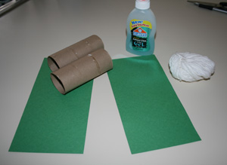[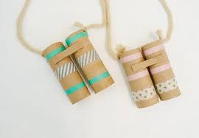](https://www.google.co.uk/imgres?imgurl=https%3A%2F%2Fnfamilyclub.com%2Fwp-content%2Fuploads%2F2020%2F04%2Fbinoculars-886x557-720x500.jpg&imgrefurl=https%3A%2F%2Fnfamilyclub.com%2Ftry-this-at-home%2Fmaking-binoculars%2F&tbnid=xAySWnDwOgYdoM&vet=12ahUKEwjb9dSYyJjtAhVqAWMBHZbPDVwQMygUegUIARDXAQ..i&docid=Rriwx36TNH-9kM&w=720&h=500&q=making%20binoculars&safe=strict&ved=2ahUKEwjb9dSYyJjtAhVqAWMBHZbPDVwQMygUegUIARDXAQ)[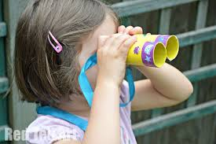](https://www.google.co.uk/imgres?imgurl=https%3A%2F%2Fwww.redtedart.com%2Fwp-content%2Fuploads%2F2014%2F06%2FBinocular-Craft-made-from-TP-Rolls.jpg&imgrefurl=https%3A%2F%2Fwww.redtedart.com%2Ftp-roll-binoculars-poppy-cat%2F&tbnid=kry6XOvixdIH0M&vet=12ahUKEwjb9dSYyJjtAhVqAWMBHZbPDVwQMygaegUIARDoAQ..i&docid=x2LmRHiXBxtfqM&w=1024&h=681&q=making%20binoculars&safe=strict&ved=2ahUKEwjb9dSYyJjtAhVqAWMBHZbPDVwQMygaegUIARDoAQ)